INFORMATION STAND
General view
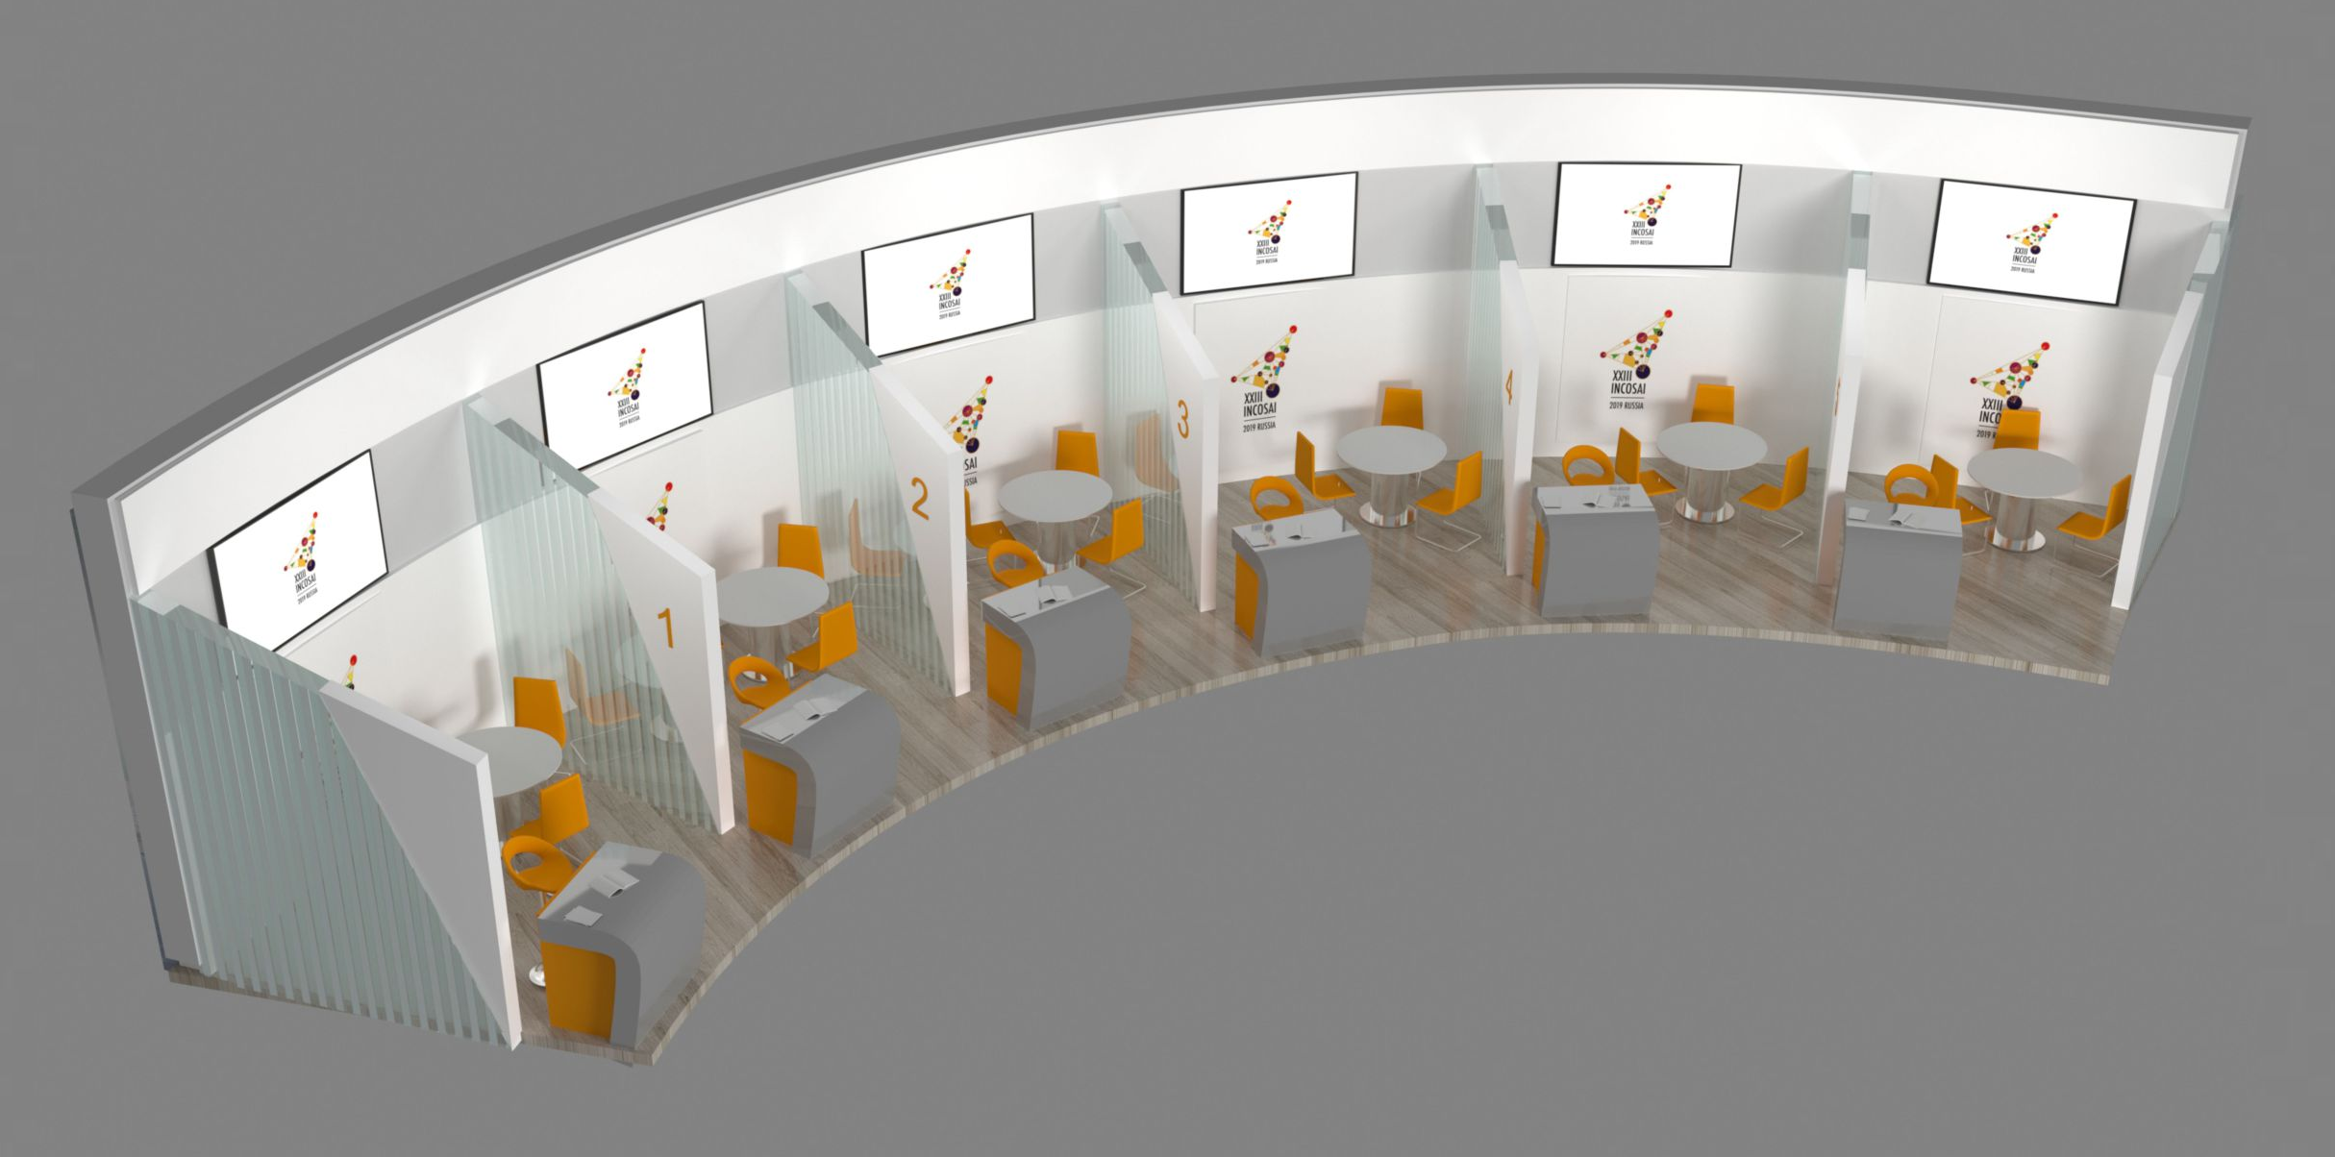

Front view

Side view Top view
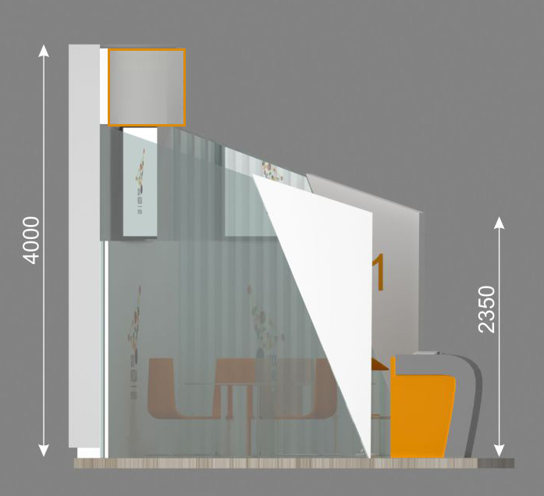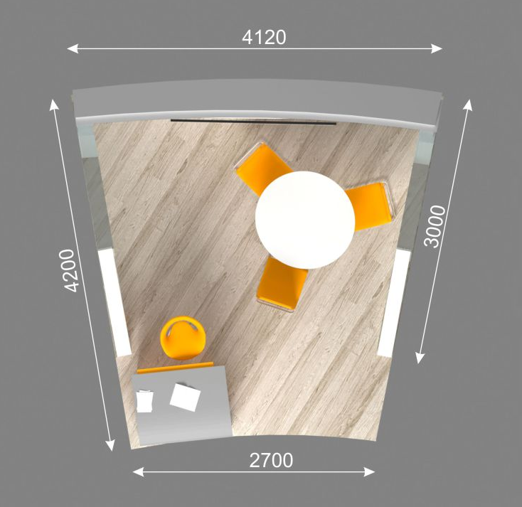
The stand has the following equipment:
- 42 ’plasma panel connected to a laptop with Internet access via Wi-Fi, as well as USB-drives
- reception desk
- bar stool
- desk
- three office chairs

Placing a logo for stand branding is possible only on a specified surface (see “Front view”).
Branding surface dimensions: 4120 mm x 750 mm.

To display your logo on an information stand you should send a logo file in vector format up till August, 1, 2019 to the following e-mail: incosai2019@ach.gov.ru.

Also we pay your attention that there will be an opportunity to use a laptop and a LCD panel during the presentation.

In addition participants may use their own roll-up displays (taking into consideration dimension of the booth), if necessary, to place their posters. Printing of posters and information materials in large quantities at the Congress site is not provided.

Please note that fastening to the walls of the stand is not allowed. Other options for branding information stand are not provided.

